Embedded Discussions
  - User Experience Preview
Contents
Overview 1
Limitations 2
Adding a discussion 2
Student view 3
Normal 3
Anonymous 4
Student 1 4
Student 2 4
Posting 5
Teacher “tag” 5
Reactions 5
Teacher view 6
Normal 6
Anonymous 6
Disqus samples 7

Overview
The “Embed discussion” feature enables threaded discussions to occur within and alongside learning content.
- It is intended as a drop-in replacement for Disqus and the embedded comments feature.
- Discussions can be anonymous (for students). Students do not see the real names of other students who have posted. They see a pseudonym, e.g. “Clever Fox”. Teachers always see real names. Students are assigned a random pseudonym per discussion.
- Teacher posts are clearly tagged.
- Discussions “rollover”. They automatically reset and do not require any teacher action before use.
- Students can edit their own posts. Teachers can edit or delete any post.
- Posts can include basic formatting (bold, underline, etc.), links and images.
- Posts can be reacted to using basic emojis. Reactions are presented in aggregate only.

Limitations
- There are no notifications or alerts. That is, there is no way to receive an email or other alert about a new post or a reply. If you require notifications, consider using the embedded forum feature.
- Posts cannot have file attachments. They can have inline images. If you require attachments, consider using the embedded forum feature.

Adding a discussion
In the editor, position your cursor where you would like the discussion, then click the Embedded discussion button, and then Embed a discussion.
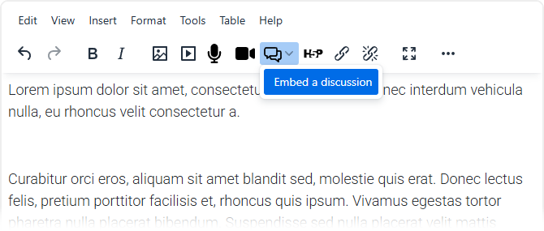

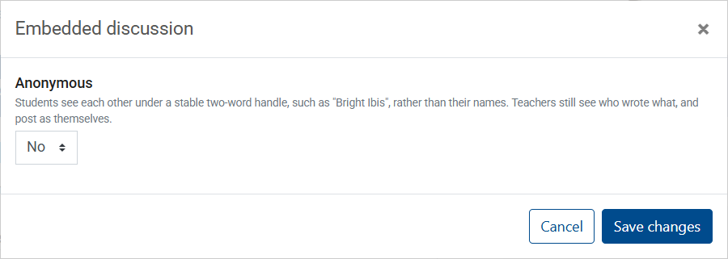
You will see a placeholder for the discussion:
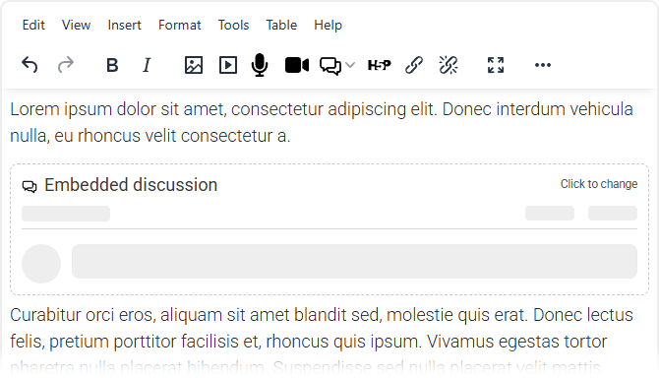

Student view

Normal
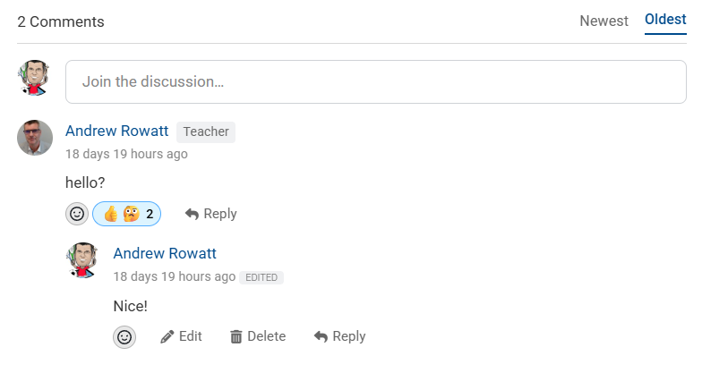

Anonymous

Student 1
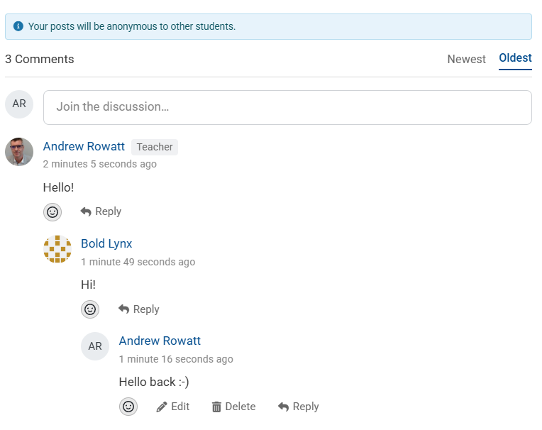

Student 2
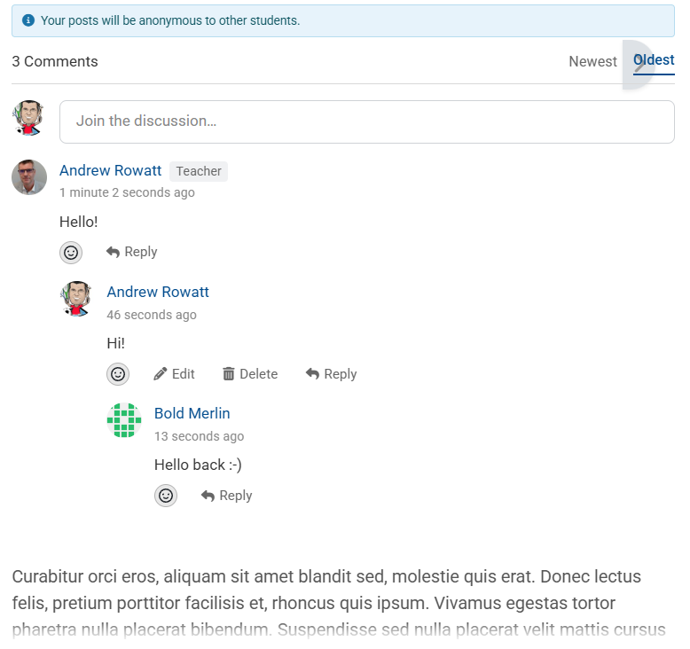

Posting
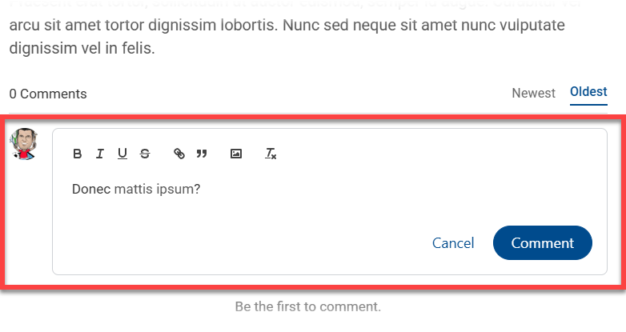

Teacher “tag”
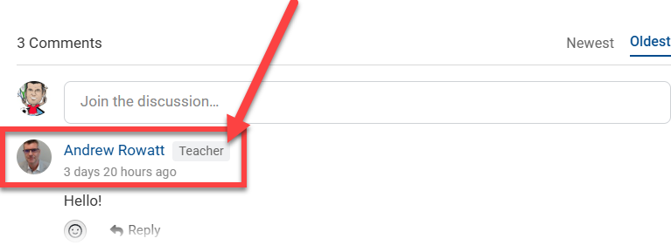

Reactions
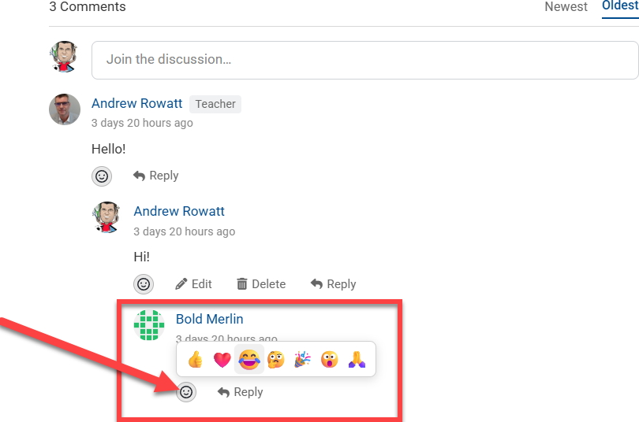

Teacher view

Normal
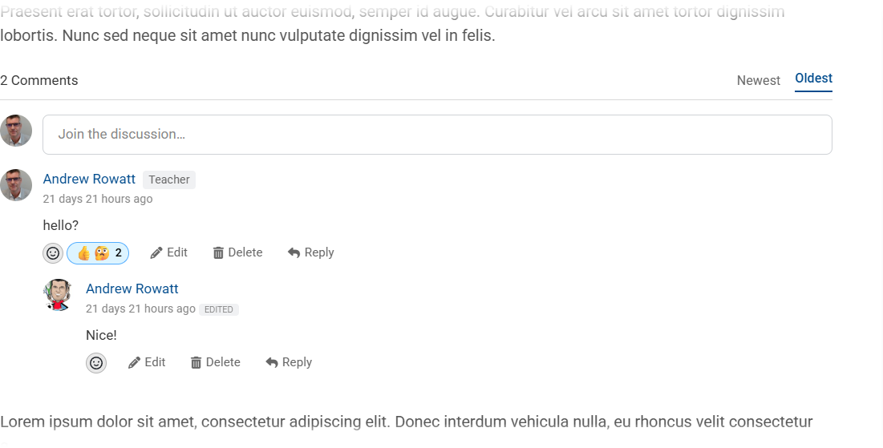

Anonymous
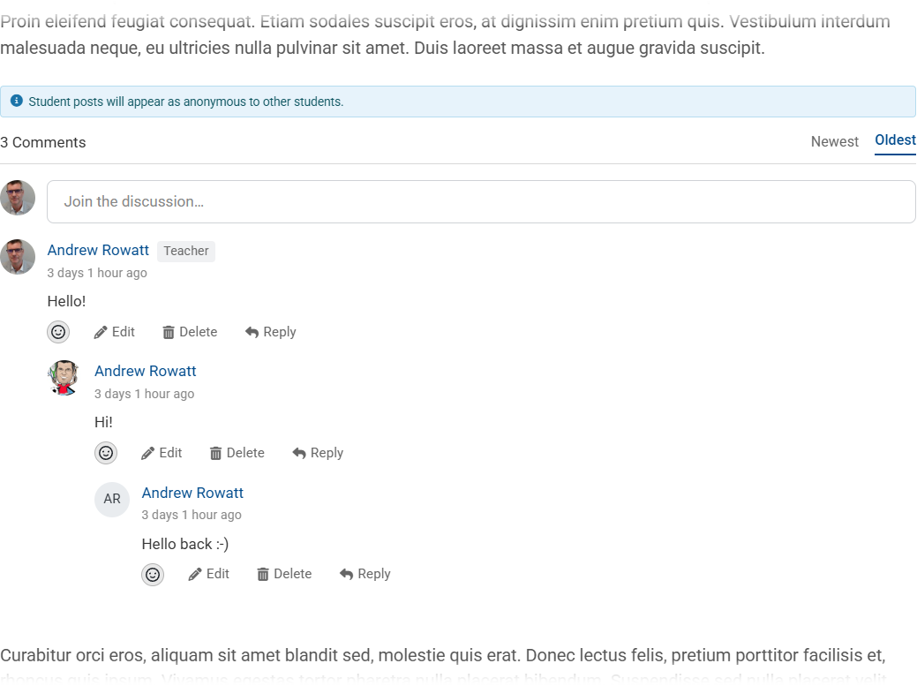

Disqus samples
Disqus is a third-party discussion provider that is integrated into Stream. The embedded discussion feature outlined in this document is hosted entirely within Stream.
https://stream.massey.ac.nz/mod/book/view.php?id=5655219&chapterid=1412870
(See below)
